SMCinema

Process Model

Mogammat Waleed Deaney 3030596

Moegammad shadley Ismail 3033569

Conal Mario Da Costa 2943393

Group 6

# Contents

1 Requirements 2

1.1 UML 2

1.1.1 UML - database 2

1.1.2 UML – Class Diagram 3

1.2 Use-Case Diagram 4

2 Specifications 5

3 Design 6

3.1 Root page 6

3.2 Movies page 6

3.3 Selected Movie Page 7

3.4 Sign-in page 7

3.5 Forgot password page 8

3.6 Specials page 8

3.7 Complaints page 9

# Requirements

## UML

### UML - database

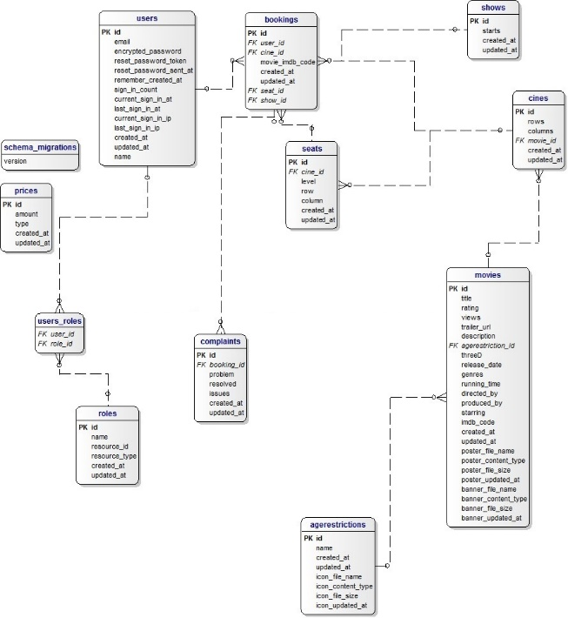

### UML – Class Diagram

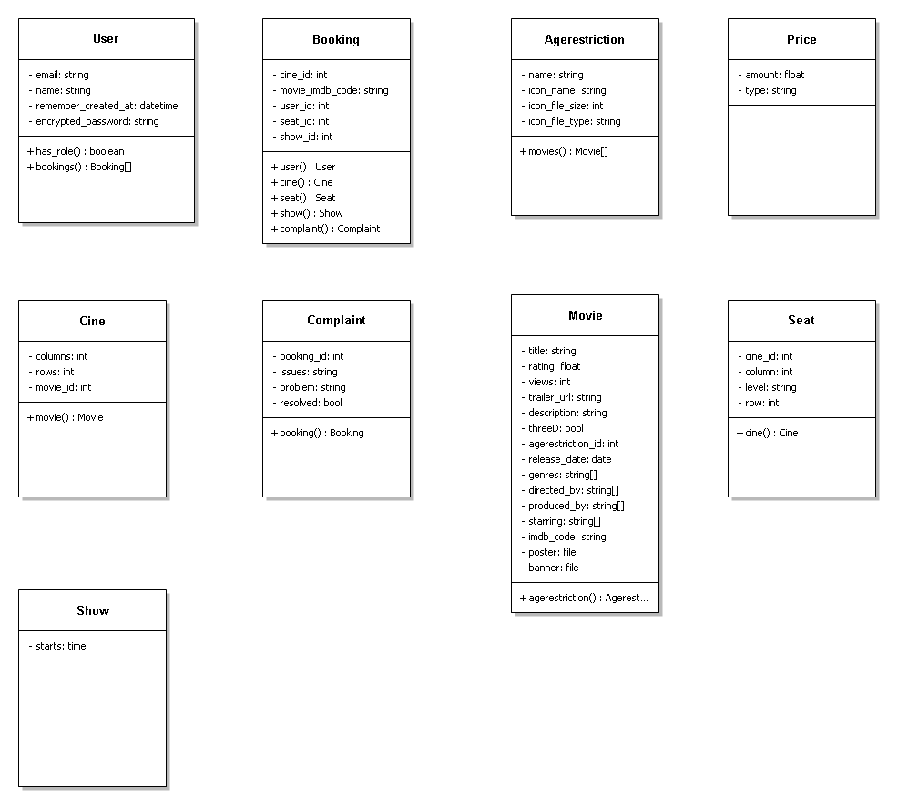

## Use-Case Diagram

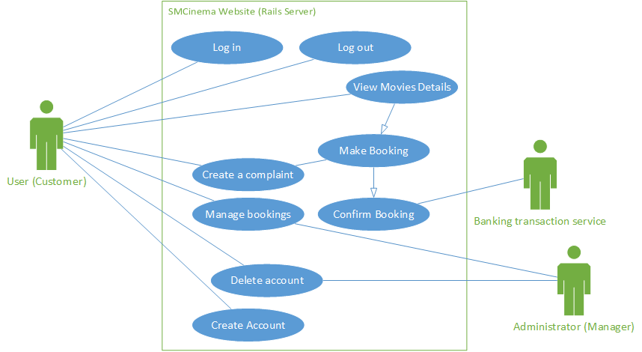

# Specifications

* Multiple user access levels (Customer, Manager)
* Monitor’s how many times a movie is watched
* Updates Movie’s details from imdb and/or tmdb
* Tracks last sign-in ipaddress
* Cross platform application
* Displays top 5 watched movies
* Displays all movies currently showing
* Allows for complaints
* Displays current specials
* Displays adverts for SMCinema confectionary store and other paying parties on each page
* Must be able to support at least 1024 simultaneous connections
* Encrypted passwords
* reset password facility
* Multiple show times per day(2pm, 8pm, 10pm)
* Allow for more show times to be added
* Handle bookings and cancellations
* Track all bookings and transactions for a management summary report
* Monitor pricing and mark-up percentages
* All users must be able to edit their own details and change their own password
* Administrator can change access level (from user role to admin role)
* New user must be able to sign up with a registration page
* filter movies by age restriction for each user

# Design

## Root page

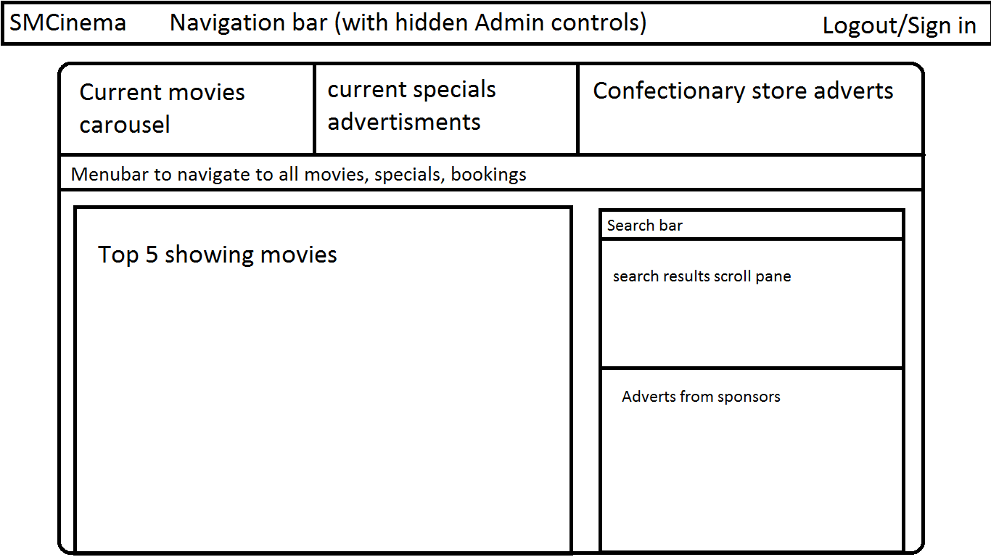

## Movies page

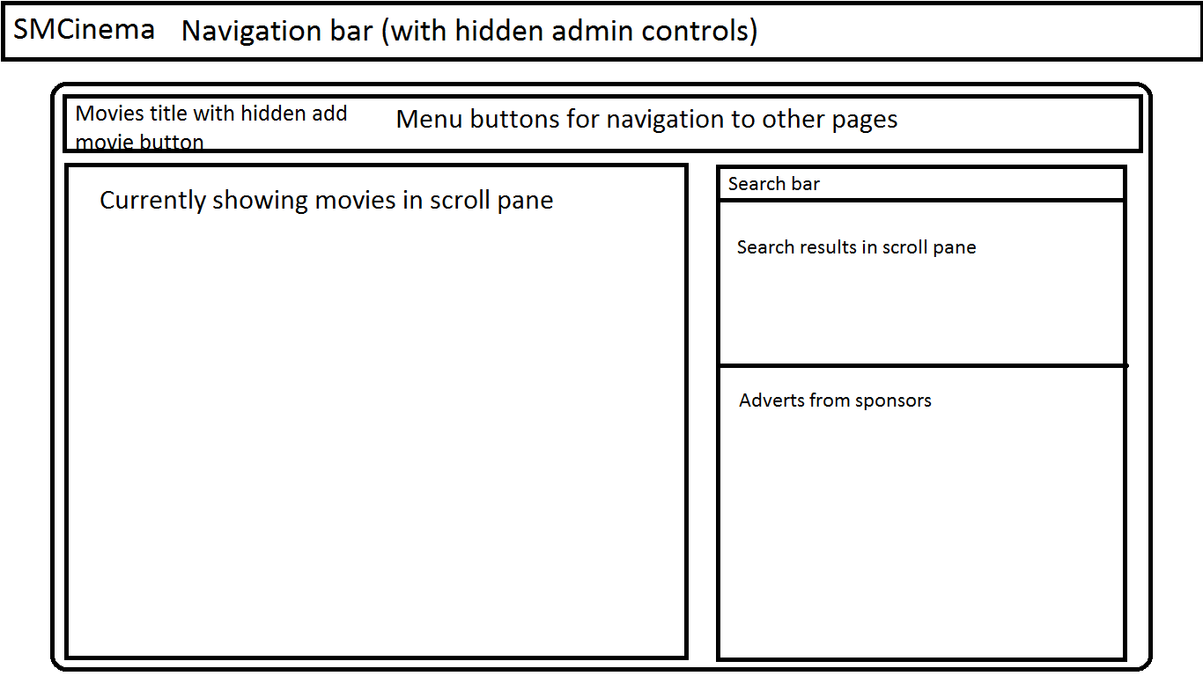

## Selected Movie Page

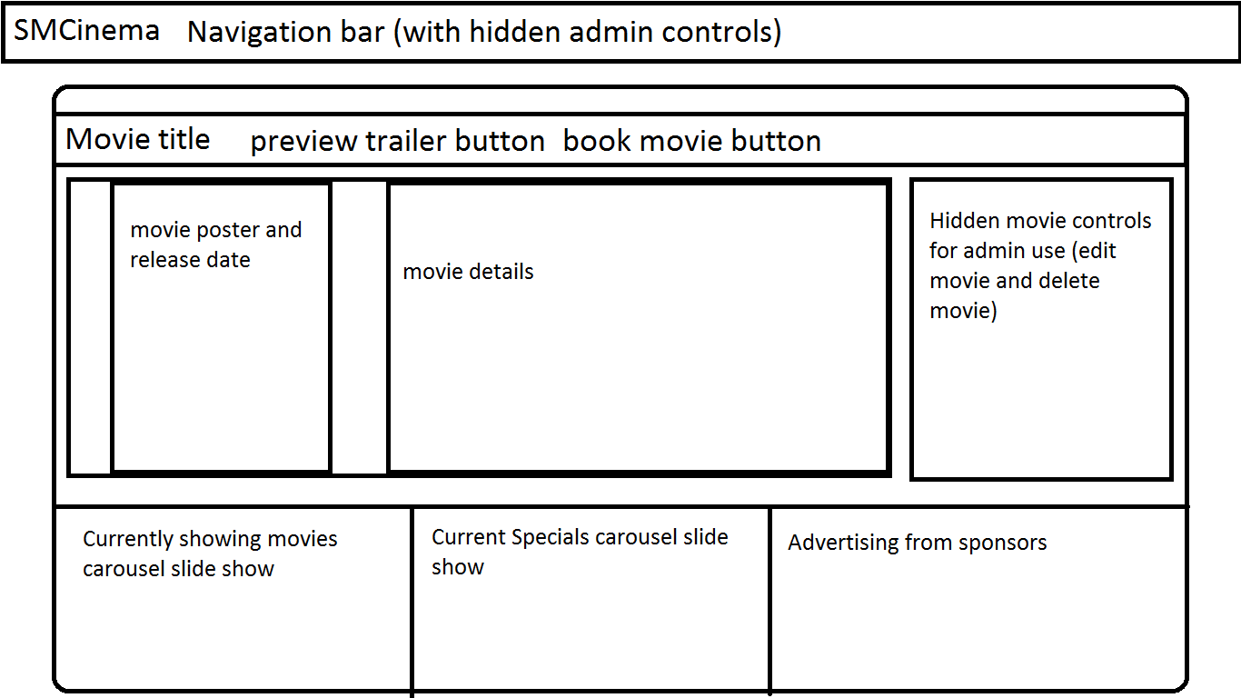

## Sign-in page

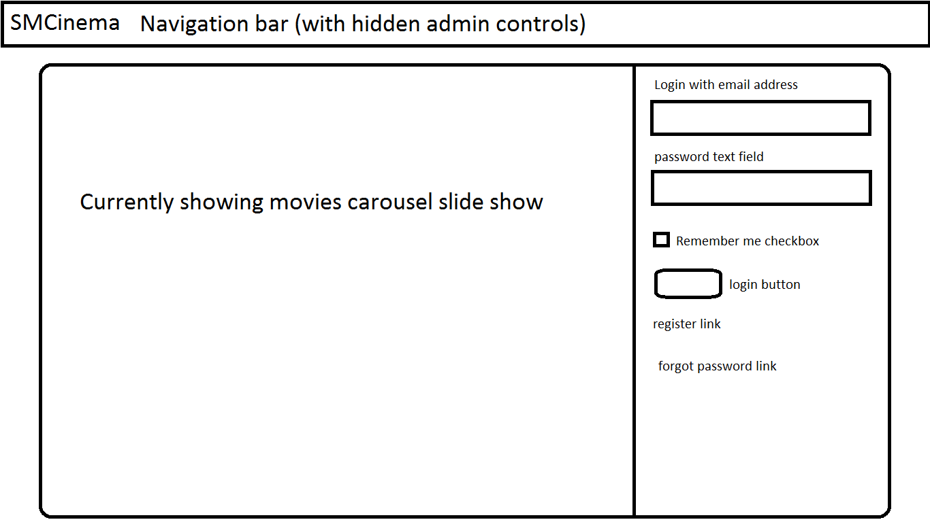

## Forgot password page

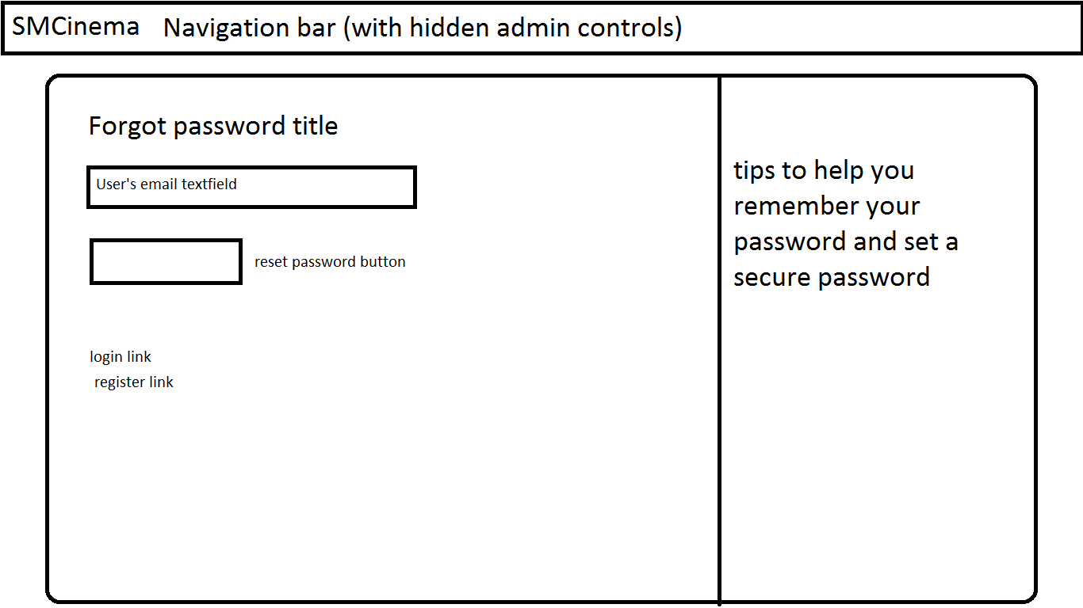

## Specials page

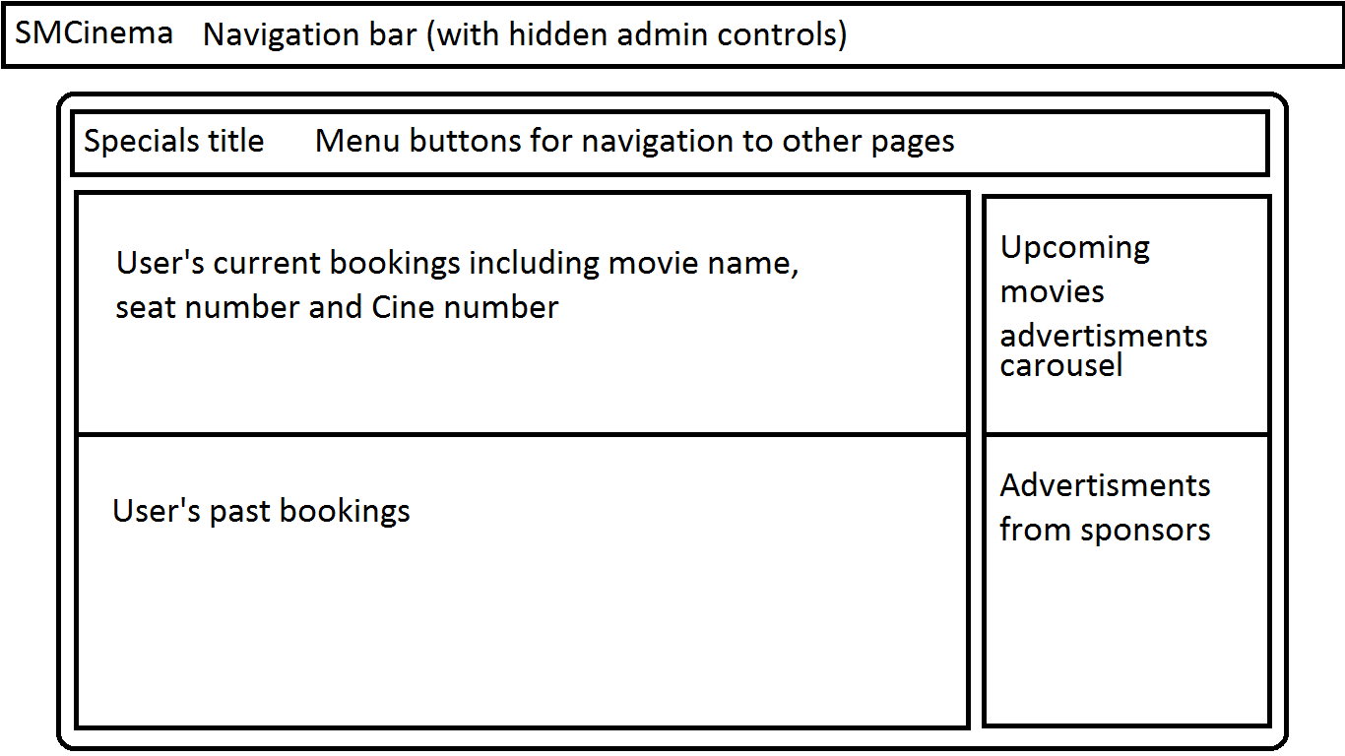

## Complaints page

